Ej. 1
20% saltos cond, 40% saltos se realizan, 18% dependencia LDE, 6% dependencia LDE
- CPI_{real} = CPI_{ideal} + (0.2 * 0.4 * 2) + 0.18 * 2 + 0.06 * 7 = 1.58
- CPI_{real} = CPI_{ideal} + (0.2 * 0.4 * 2) + 0.18 * 0.3 = 1.214
- sped up = 1.58/1.214 = 1.3

Ej.3
add x1, x2, x3
sub x4, x2, x6
addi x5, x4, 3
lw x6, 4(x2)
add x5, x2, x4

a)

RegWriteD | 1 | RegWriteE | 1 | RegWriteM | 1 | RegWriteW | 1
ResultSrcD | 01 | ResultSrcE | 00 | ResultSrcE | 00 | ResultSrcW | 00
MemWriteD | 0 | MemWriteE | 0 | MemWriteE | o
JumpD | 0 | JumpE | 0
BranchD | 0 | BranchE | 0
ALUSrcD | 1 | ALUSrcE | 1
ImmSrcD | xx | ALUControlE | 010
ALUControlD | 000 | ForwardAE | 10
 |  | ForwardBE | xx

PCPlus4F | 0x2014 | RD1IE | 0x7
PCPlus4D | 0x2010 | RD2IE | xx
PCPlus4E | 0x200C | SrcAE | -2
PCPlus4M | 0x2008 | SrcBE | 3
PCPlus4W | 0x2004 | ALUResultM | -2

Ej.4
add x1, x2, x3
lw x6(4x2)
sub x4, x2, x6
and x5, x2, 3
add x5, x2, x4

RegWriteD | 1 | RegWriteE | 1 | RegWriteM | 1 | RegWriteW | 1
ResultSrcD | 00 | ResultSrcE | 00 | ResultSrcE | 01 | ResultSrcW | 00
MemWriteD | 0 | MemWriteE | 0 | MemWriteE | 0
JumpD | 0 | JumpE | 0
BranchD | 0 | BranchE | 0
ALUSrcD | 1 | ALUSrcE | 0
ImmSrcD | 00 | ALUControlE | 001
ALUControlD | 010 | ForwardAE | 00
 |  | ForwardBD | 01

PCPlus4F | 0x2014 | RD1IE | 0x0004
PCPlus4D | 0x2010 | RD2IE | 0x0006
PCPlus4E | 0x200C | SrcAE | _0004
PCPlus4M | 0x2008 | SrcBE | _0008
PCPlus4W | 0x2004 | ALUResultM | -4

Ej 6
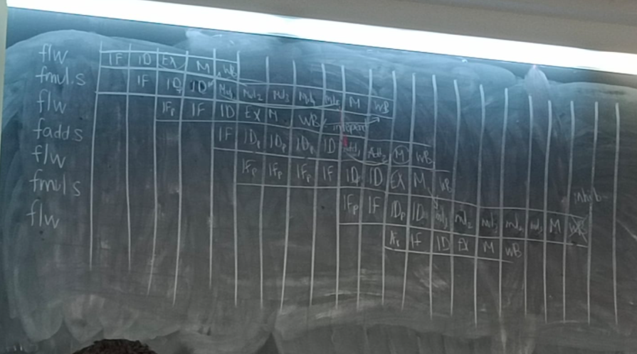
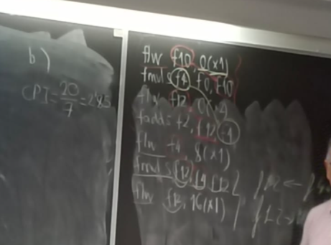

Ej7

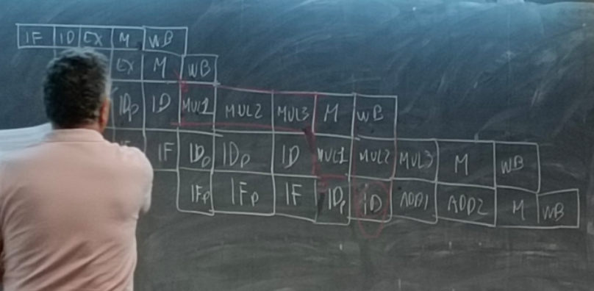
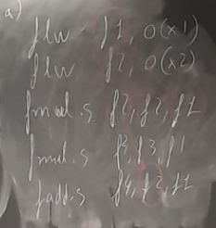
b )
c )
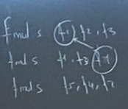
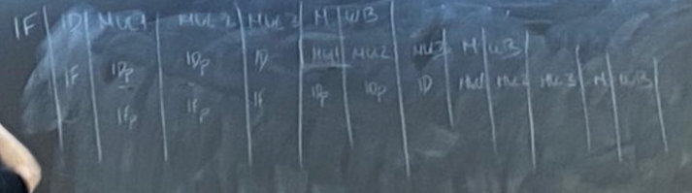
d )
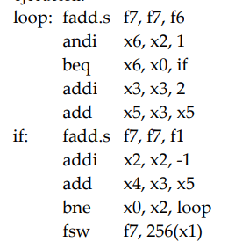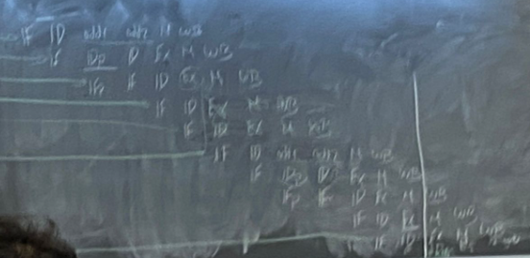

Ej 8
